Assignment 3:

Pressure Alarm Systems -

A simple solution to a problem that affects many

Name: Alvin Pang and Francis Nacional

Tutor: Jason Free

Tutorial: Thursday 1600-1800

# Table Of Contents

**Table Of Contents** **1**

**1. Abstract** **2**

**2. Introduction** **3**

**3. Project Design** **4**

3.1 Project Idea 4

3.2 Design Problem 5

3.3 Design Process 6

**4. Project Solution** **7**

4.1 Technical Solutions 7

4.2 Development Process 9

4.3 Project Prototype 12

**5. Summary** **13**

**6. Appendix** **14**

**7. References** **15**

# 1. Abstract

This report outlines the process that Alvin and Francis took to analyse and find a solution to a problem that both team members are experiencing using the topics and directions from the Emergent Technologies and Interfaces curriculum and teaching faculty.

This report introduces the current automotive security problems the team has identified through the use of current statistical data and analyses the problem briefly in order to justify their research. The team then outlines the process they have undertaken to come up with the project idea and present it to the faculty for approval. The report also outlines the problems the team were facing with regards to designing the actual product. The report will then outline the solution the team proceeded with and developed into an actual product. Finally, the report will summarise what the team found during the project development.

# 2. Introduction

With the rise of vehicle theft over the years, vehicles becomes an expensive and risky asset as people have a risk of losing their vehicle when it is parked.

Majority of the vehicles are equipped with security features such as alarm system, immobilizer, dash camera but there are still a increasing numbers of car theft. Thieves are able to bypass the alarm system or able to deactivate the alarm system without it sounding off.

The aim of this project is to solve current technology’s problems by inventing a new product.

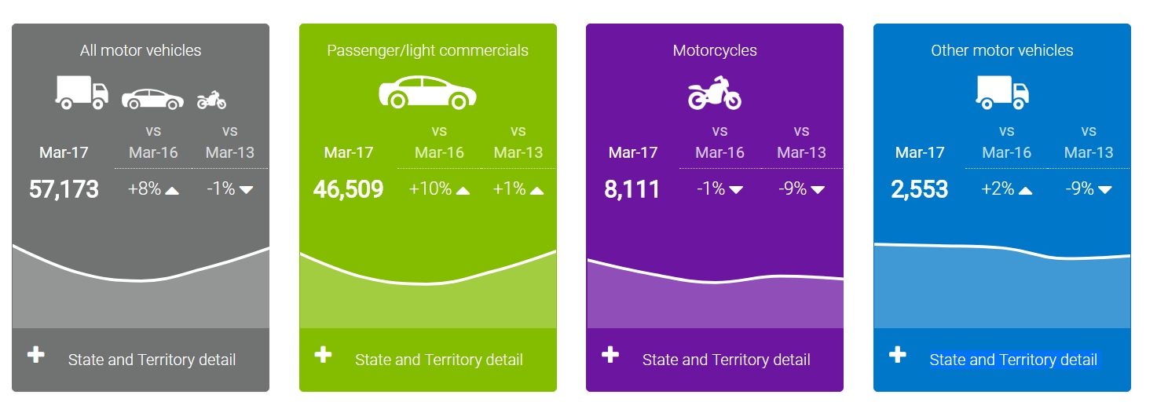

This is the statistic data of car thefts happening in Australia in 2017 and this statistic shows that in 2017 there is a 10% increase in theft for passenger/light vehicle compared to 2016 and a 8% increase for all motor vehicles.

# 3. Project Design

## 3.1 Project Idea

This project idea came about when Alvin and Francis share the same hobby which is modifying/repairing their own vehicles. Alvin owns a car and Francis has a motorcycle so they decided to have a project which is related to what they love to do during their free time which benefits to both car and motorcycle.

While searching for an idea, Alvin saw an article on the news which reported that this year there is an increasing number of vehicle theft. Alvin, a car enthusiast, has tried to find ways to make vehicles more secure and prone to theft. Nowadays, the current car alarm system is useless as thief know how to bypass the alarm system.

After discussing with Francis, they came out with an idea to make both cars and motorcycles even more secure. Francis who is a motorcycle enthusiast, mentioned that in this current market, there is no decent alarm system for motorcycles and the team proceeded to begin doing research for a similar product available in the current market.

The team wants to have a product which can save the environment by minimizing waste of resources, making vehicles more secure and building the product cheaply.

## 3.2 Design Problem

The design problem our team faced is whether if the actual design works as both of our team mates have no engineering background and were unfamiliar with circuit, current and resistor. One of our team mates, Alvin, who has experience fixing car electrical component decided to give it a try and after doing many hours of research and trial and error, he managed to come up with a smaller system and by replacing the pressure sensor with another switch, he managed to get it working.

The actual design diagram that our team created was not accurate enough as there are some cables missing but using the diagram helped our team with the concept of how the whole system works.

Another problem our team faced is that we want to spend as little money as possible for the prototype.

The current working design has a disadvantage which is the cable connectors we are currently using in our prototype do not use water resistant connectors and the pressure sensor will need to be physically placed on the seat cushion which require our team to figure how can we place the sensor without cutting a hole in the current seats.

## 3.3 Design Process

The design process on the whole prototype is pretty straight forward.

In the first part of the design, a rough diagram was sketched and thinking of ways to build a pressure sensor with common hand tools. We also wrote down the items needed to create the whole system such as cables, alarm, switch, relay, GPS module etc.

After knowing what items are needed, we will need to know more technical in depth of the items needed e.g what kind of Amperes do we need for the cable and what kind of voltage is needed for the whole system to work.

We needed to source our power from a 12v battery. After all those items have been noted down, we needed to start looking for relays which are suitable for our application as there are many types of relay, each having different functions and it must be an automotive relay as other relays do not work with DC 12v battery.

After finding a suitable relay, we needed to know what port of the relay does what functions. Many hours were spent on researching on the relay connectivity.

After that, we managed to slowly build our system section by section, part by part and many hours of trial and error, we managed to finish up the actual working system and this system allows for future expansion and potential upgrades.

# 4. Project Solution

## 4.1 Technical Solutions

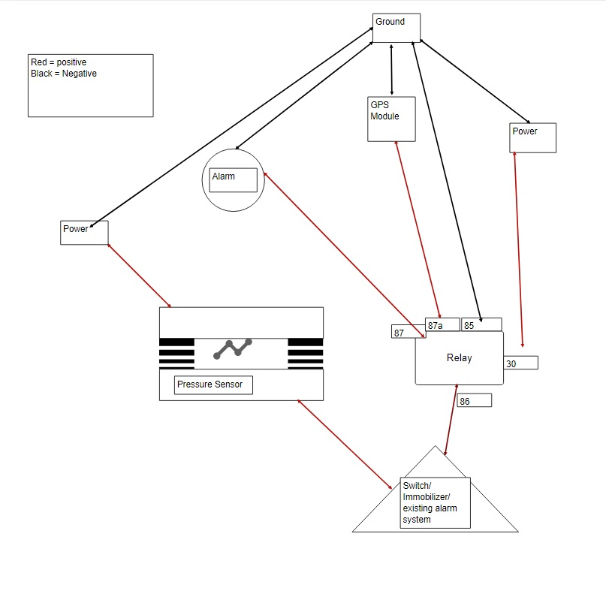

*Image a. Simplified diagram of the system*

The pressure sensor is made out of 2 metal sheets and there is springs/foams located between the 2 metal sheets. In the middle, there is a conductor which is attached to one metal sheet.

When pressure is applied, the spring will contract which allow the metal conductor to touch the other metal sheet and it will cause an close circuit.

One sheet is connected to the power source while the other is connected to a switch.

The switch is connected to the relay and other is connected to the sensor.

The Switch in the diagram represent the car/motorcycle immobilizer or the current alarm system. User can attached to either the immobilizer or the existing alarm system or both.

GPS module will be turned on with the alarm. The GPS module has a valid Sim Card which has 3G data and it will sent a sms of its location to the owner’s phone. Owners can also track their location by opening a app. It has live tracking, power cutting functions for owner to use.

Relay :

Port 85 - Ground

Port 86 - Power

Port 30 - Power

Port 87 - Alarm

Port 87a - GPS module

When the power and ground is connected to a power source, The power will activate the sensor, when the sensor is in an open circuit, no alarm will sound off but when the sensor is in an closed circuit, which mean there is a pressure applied to the sensor, it will sent a electric current to the switch, now it is dependant of the switch, if the switch is turned off, the alarm will not be activated as there is no electric current passed to the relay port 86.

If the switch is turned on, it will pass an electric current to relay port 86 and it will trigger relay port 87 and 87a to a closed circuit and electric current able to pass through to the alarm and GPS module.

This product will work on DC 12V battery which is suitable for all automotive vehicle which are using DC 12V battery.

All the cables will be hidden on the chassis of the vehicle and all the cable used will be in black in color to prevent theft from bypassing it or deactivating the system.

The alarm will be mounted either at the engine bay or it will be installed under the vehicle so it will not be found easily.

All cables and connector will be a water resistance cable or connector to prevent it from short circuit. All cables must be wrap with an insulator to prevent heat from the car’s engine.

## 4.2 Development Process

The development process is where individual prototype component needed is described with pictures below.

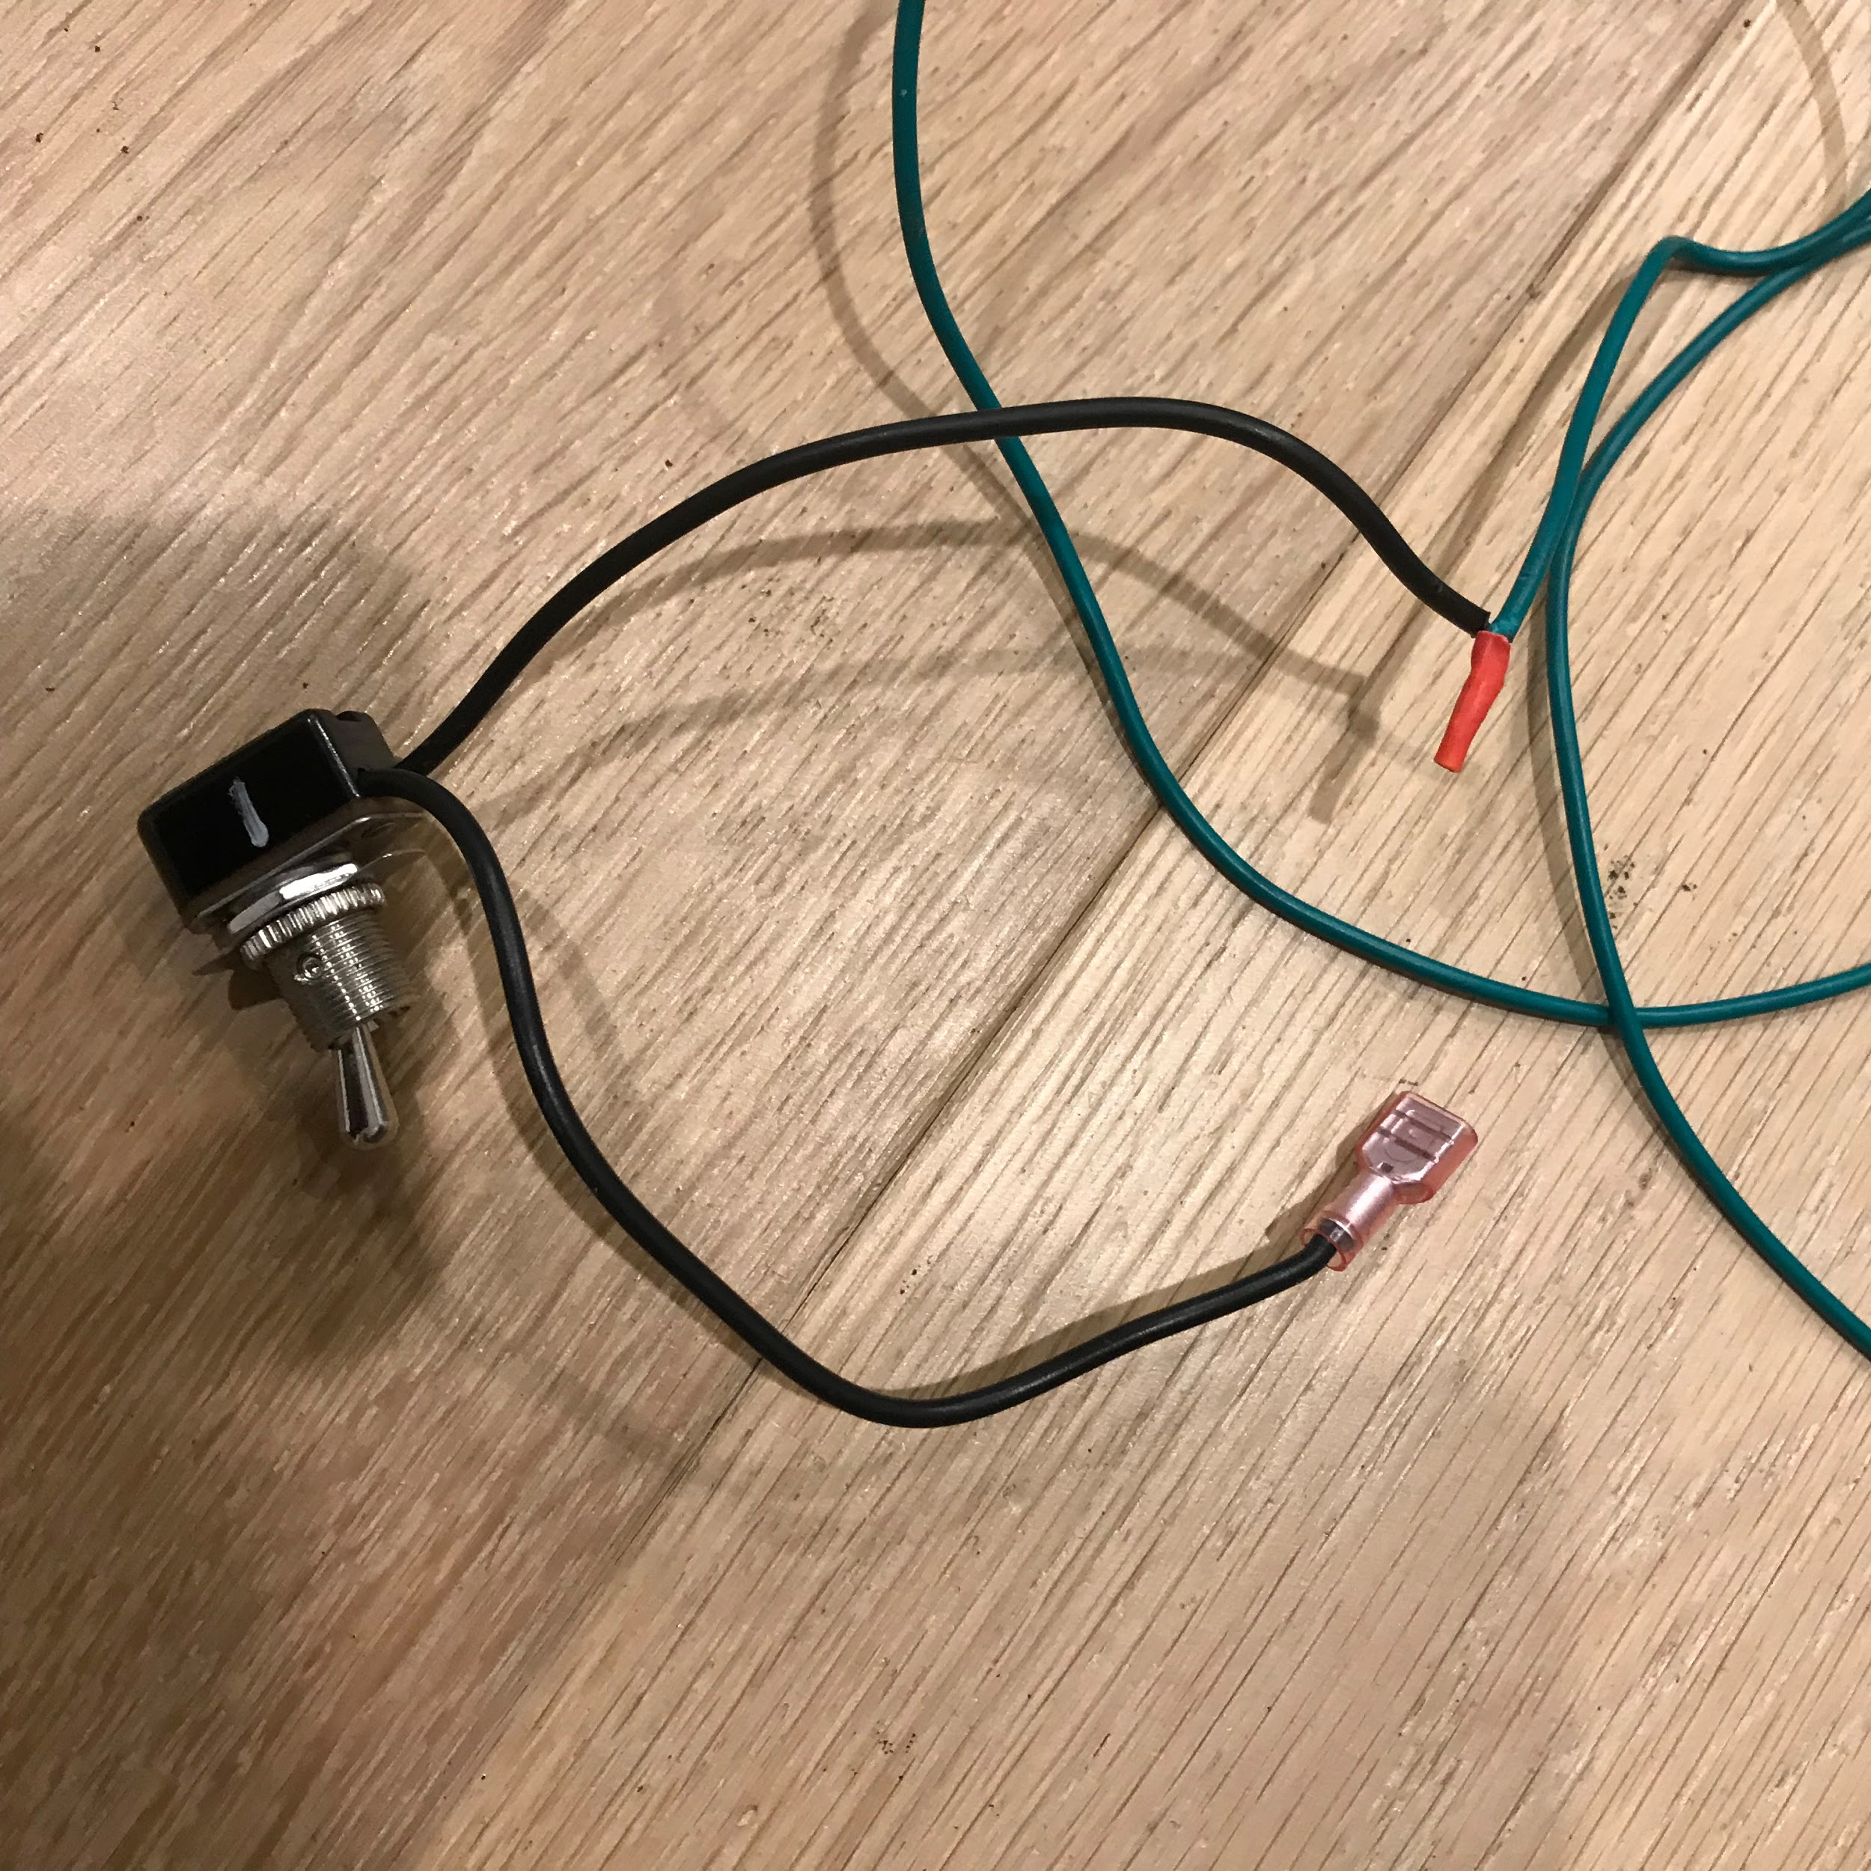

*Image b. Switch representing an immobilizer/alarm system.*

This is the switch which represents the immobilizer or the existing alarm system. It is connected to the relay and the sensor. It has an on and off function.

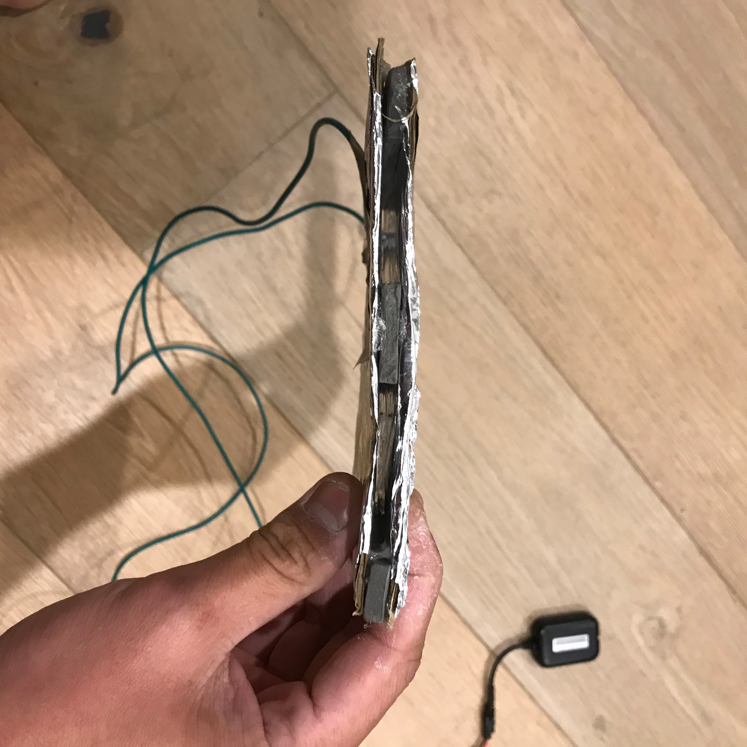

*Image c. Pressure sensor.*

This is the pressure sensor which is created by our team and it has a conductor in between the two sheets of metal. Each sheet has a cable connected to it. The two metal sheet is separated by many foams which prevent the two metal sheet from touching each other when no pressure is applied.

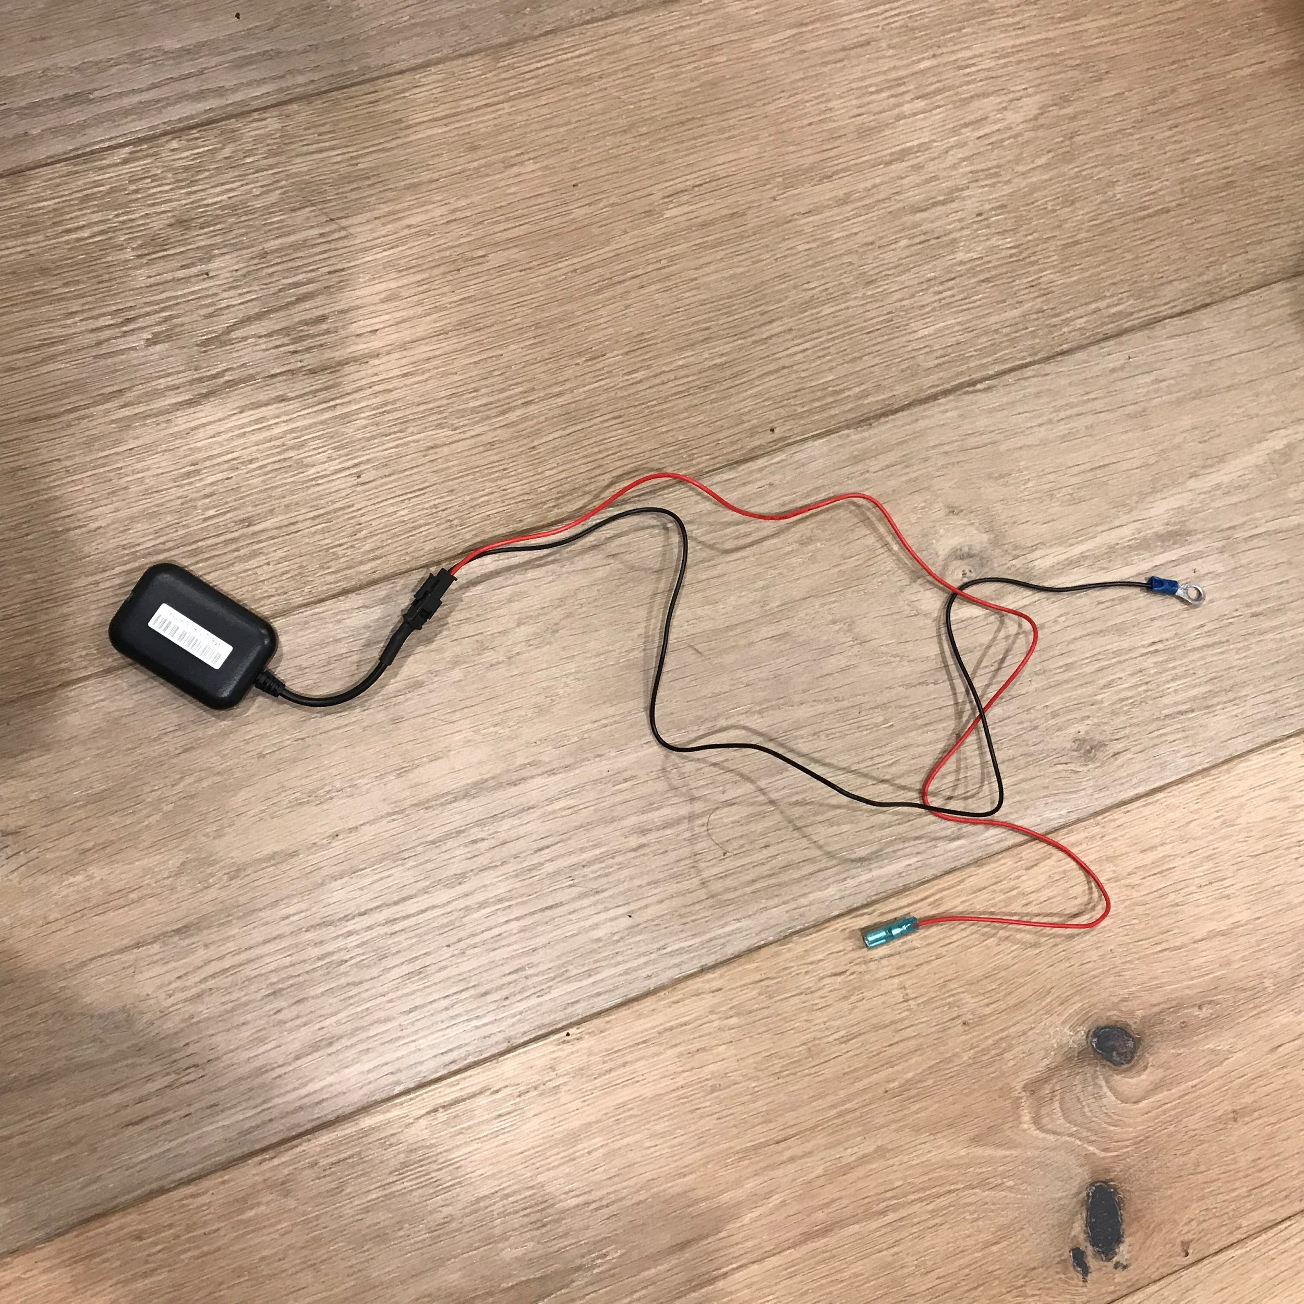

*Image d. GPS module.*

This is a GPS module which has a 3G data sim card installed. It allows the vehicle owner to track the location and have functions such as power cutting, live GPS, speed and voice recording.

The owner is able to track their vehicle using SMS or it can send an update of its location every 30mins. It has a water resistance connector and the module is small and easy to hide in a car or motorcycle.

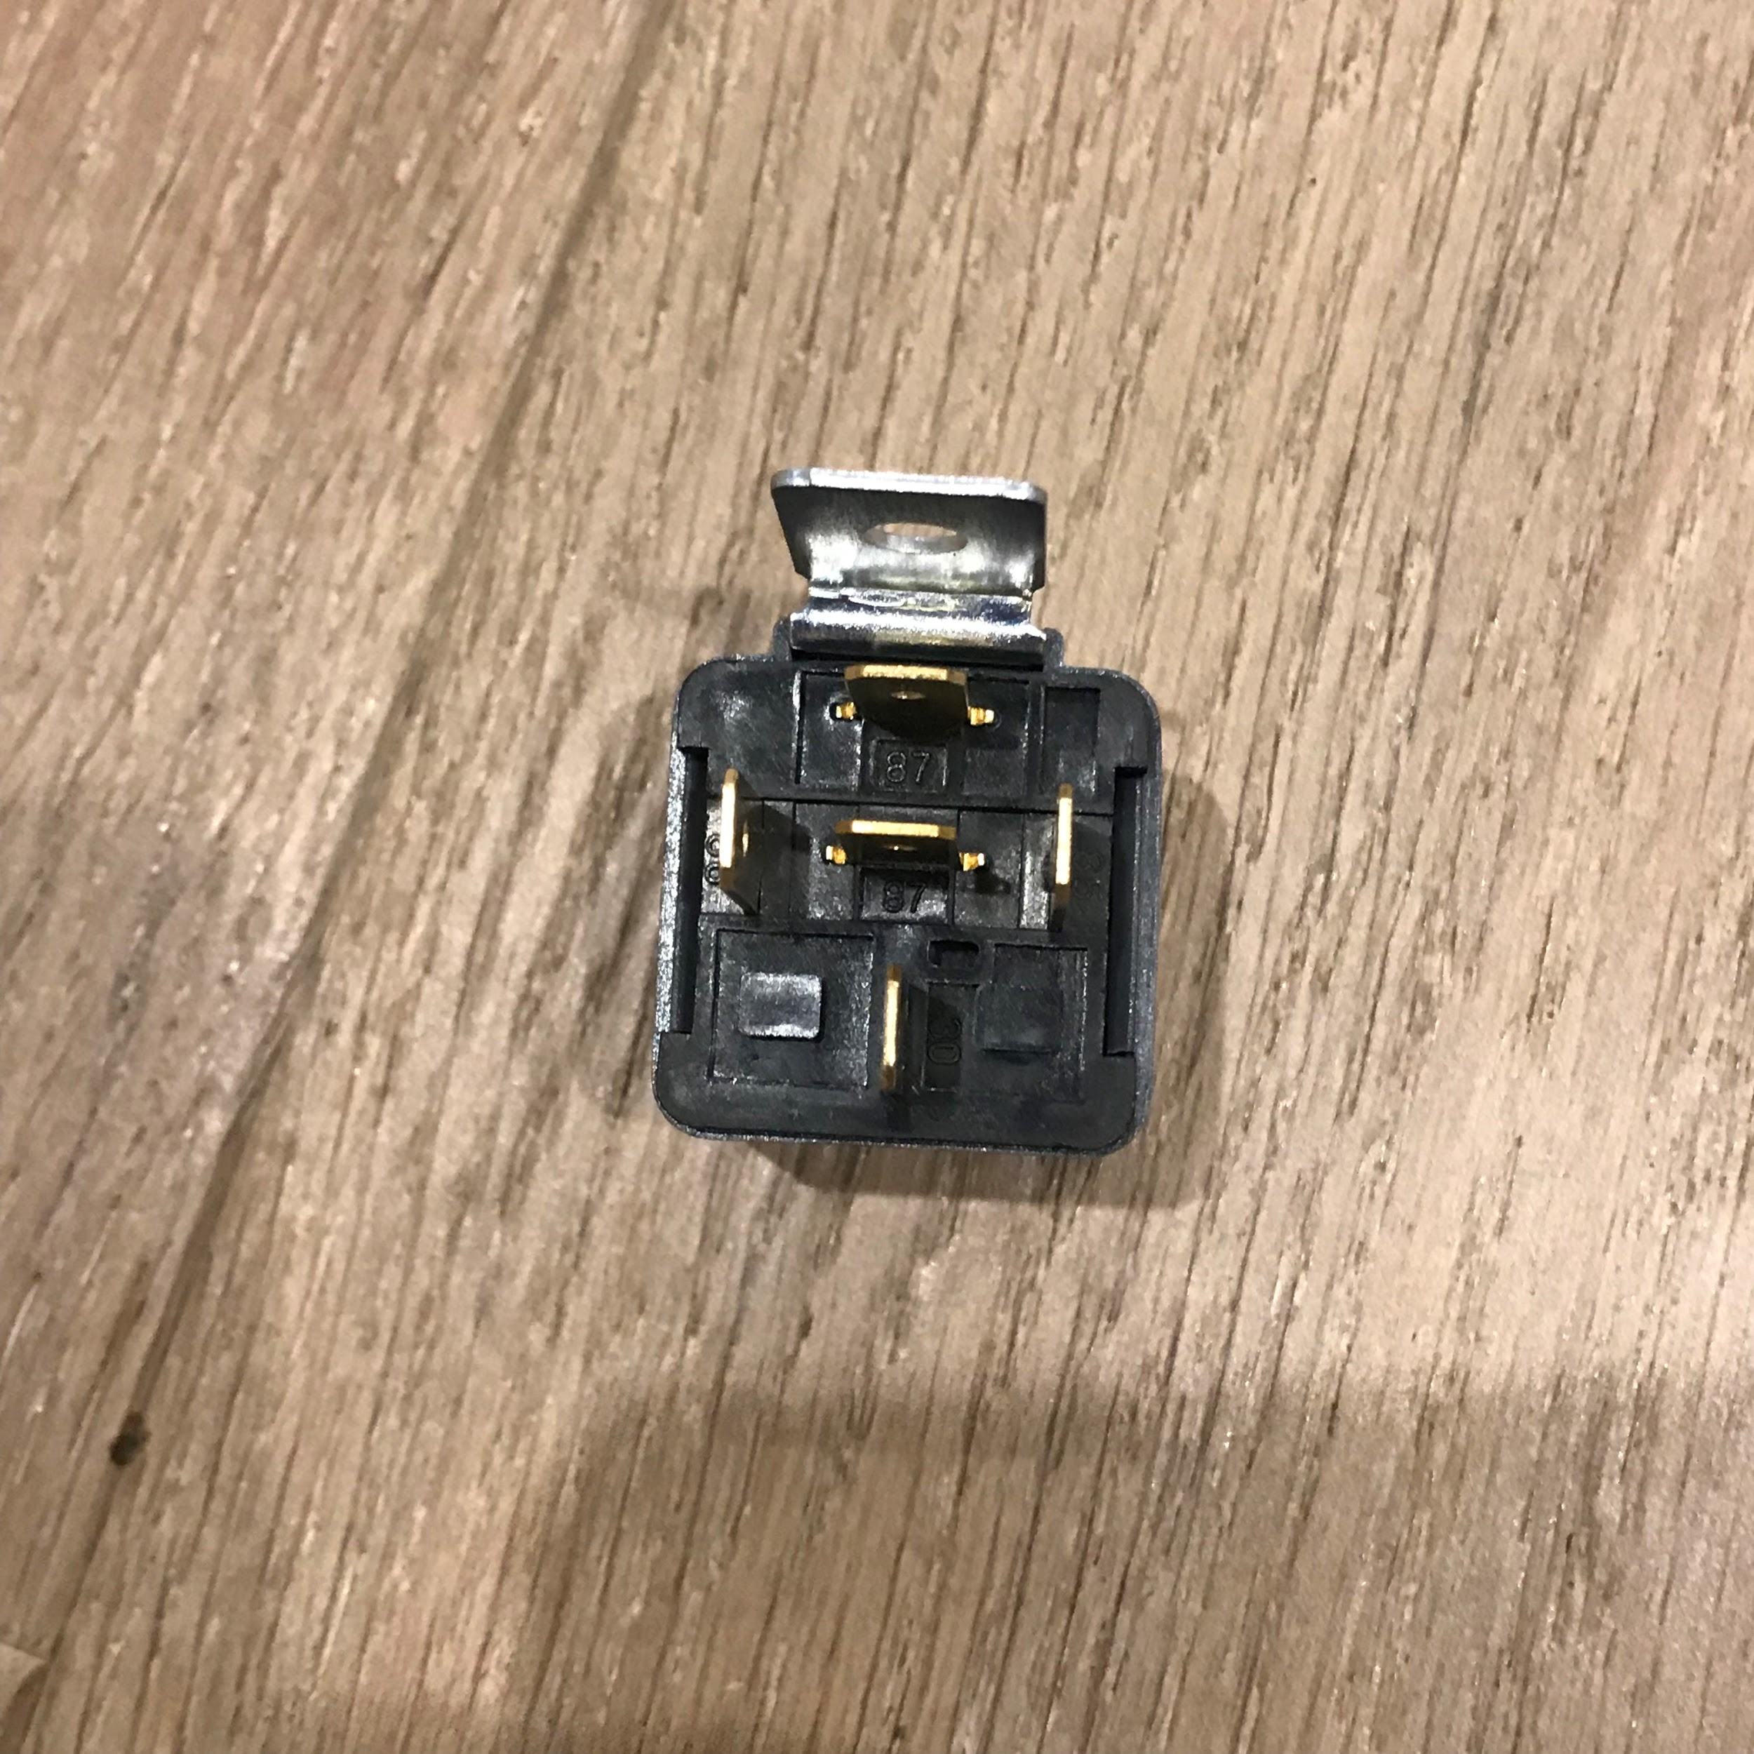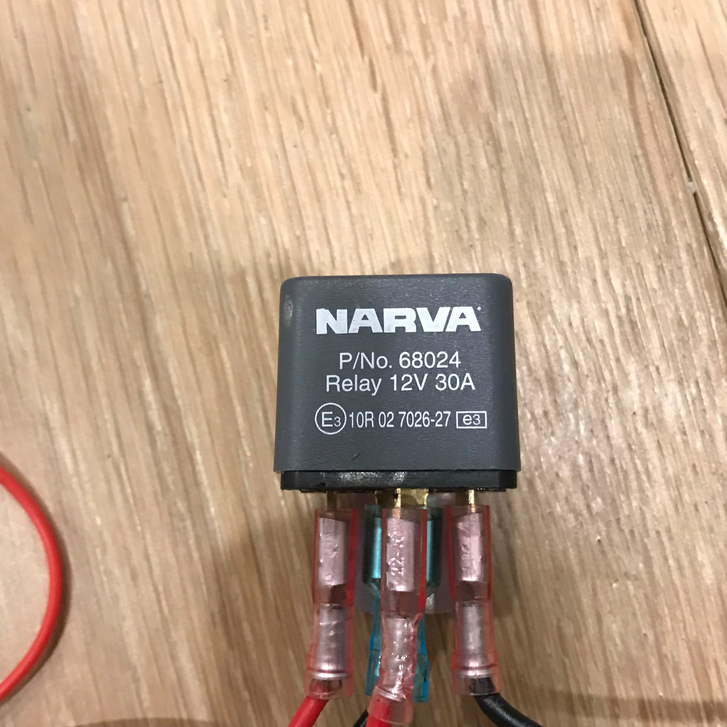

*Image e. Automotive relay showing (a) connectors and (b) identification*

This is a 12V relay which act like a switch but it has lots of ports. Usually a relay can be found in any automotive vehicles. This relay is specially designed for automotive headlights or taillights.

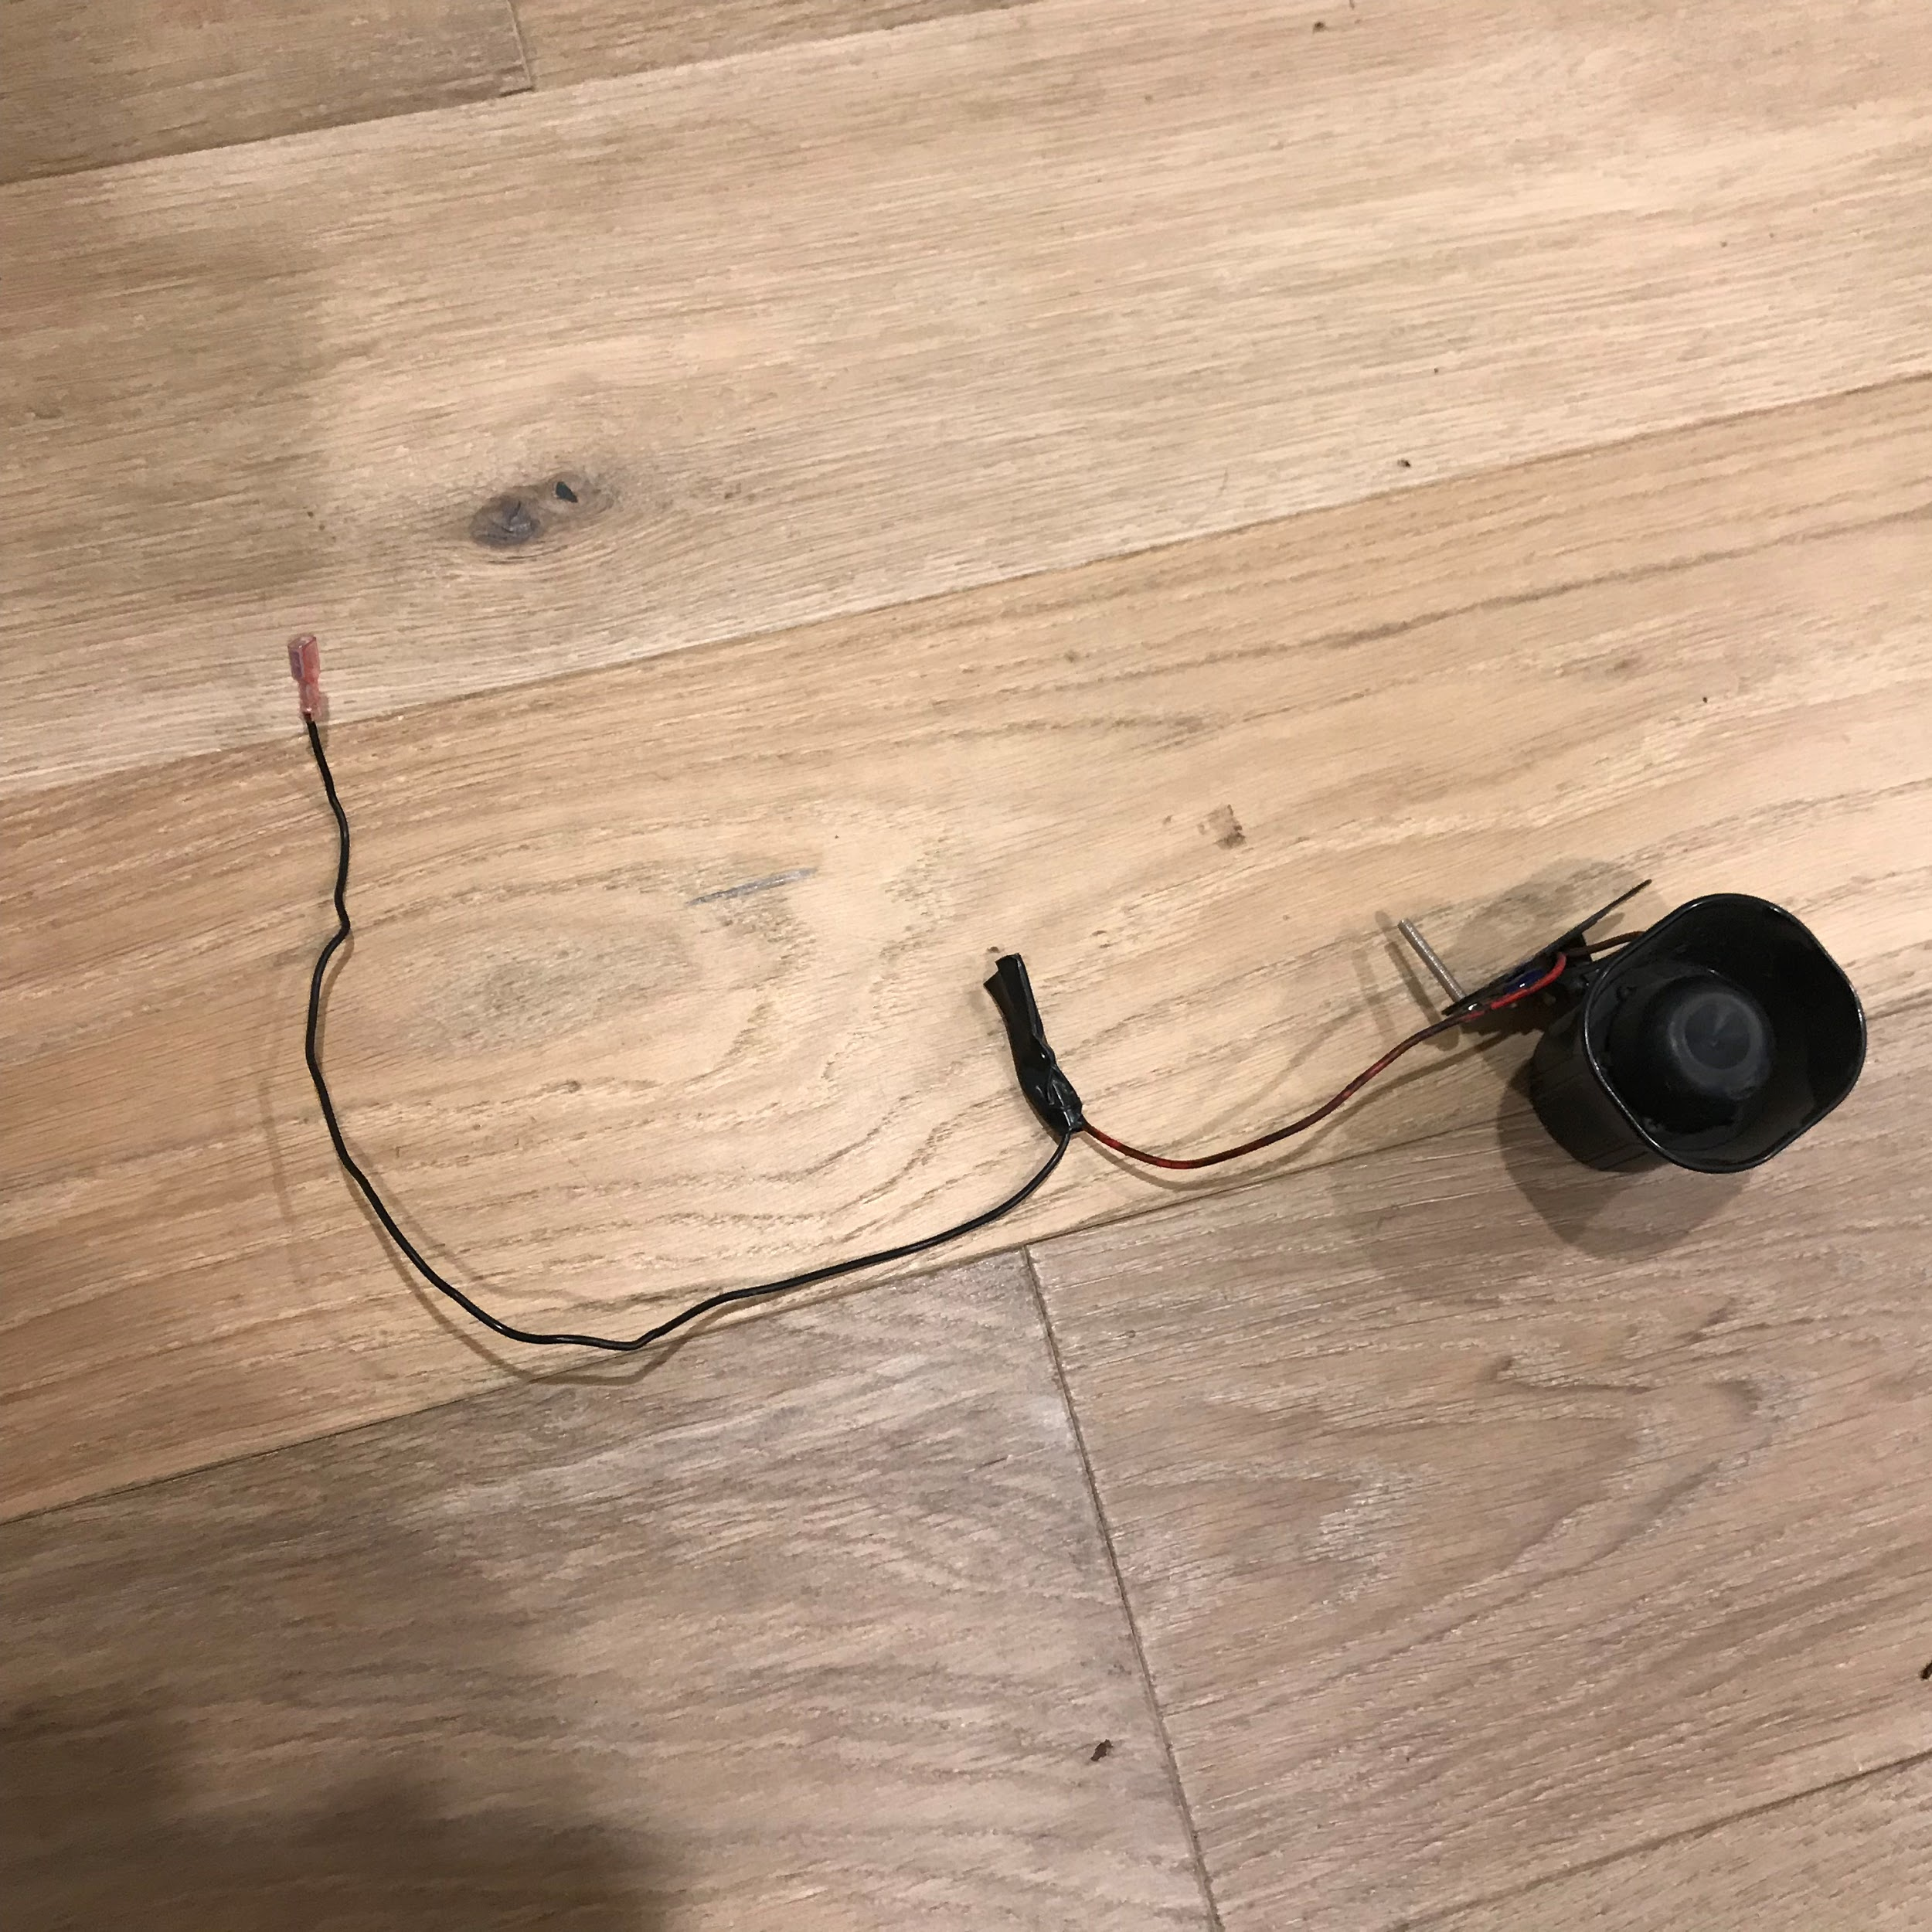

*Image f. Alarm speaker.*

This is an alarm speaker which are used in automotive vehicles and it can produce 200 db of noise. It is running on 12V DC battery and it is water resistance. Usually found in car’s engine bay.

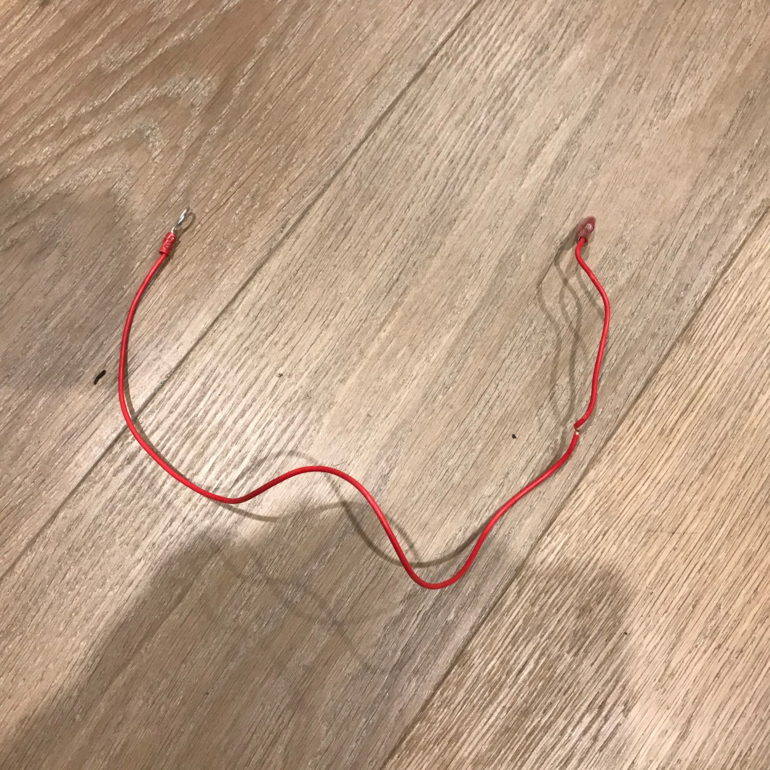

*Image g. A cable*

All cables used in this project were automotive cables which can withstand 10A-15A of electric current. These cables exceeds what a vehicle outputs throughout its own system.

## 4.3 Project Prototype

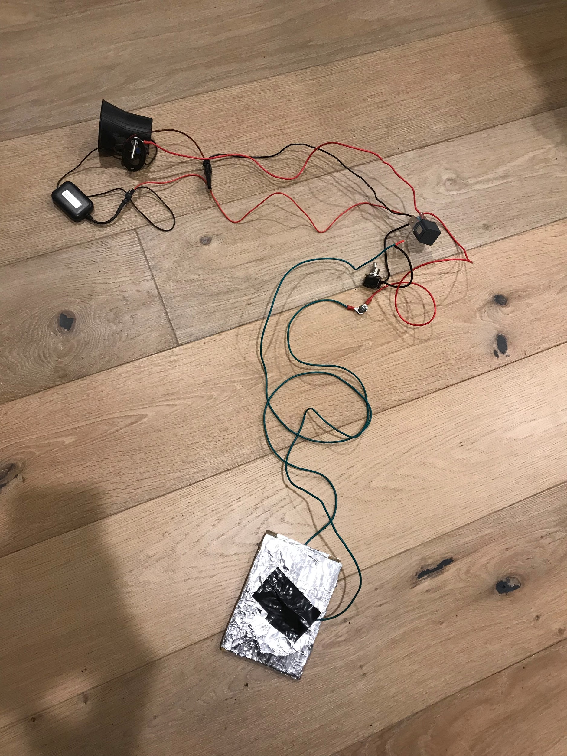

*Image h. The Actual Working Prototype*

The outcome of our prototype turn out to be a working prototype and it does what is expected. This prototype can be used on any vehicles and it is easy to install. We will be planning to add more additional features to make it even better in the future.

Our next plan will be getting funds by using kickstarter and start producing the real product which can be installed in vehicles.

Majority of the items needed for this project were found in used old car from various wreckers as our team want to protect the environment by reusing the old items and most of this items are still in a good working condition. The price for those item is cheaper than buying it brand new. We might even sell this idea to a car alarm company which specialize on car security and they could have a better choice in adding more features.

# 5. Summary

This project was very technically challenging. There were a lot of trial and errors involved, and prototypes were designed and discarded just as quickly as they were built. However, what the team found on the completion of this project is that the best way to find the solution to a problem is through iteration.

Although the product seems to be completed, there are still a number of improvements that can be done, not only to increase its capabilities but also improve what it originally was meant to do.

This project solves two problems at once. Not only does the product make vehicles more secure as an addition to existing alarm systems via the use of the GPS module to track their vehicle with their smart devices, the fact that it can be built using existing products makes the product a low cost and relatively low impact not only to the vehicles already on the road but to future vehicles and the environment as well.

By reusing the items that are already available for us, we are saving the environment by minimizing waste and making it to fulfil what technology is still lacking.

# 6. Appendix

|  |  |  |
| --- | --- | --- |
|  | **Alvin** | **Francis** |
| **Prototype Design** | **60%** | **40%** |
| **Purchase of Items for building prototype** | **100%** | **0%** |
| **Prototype Build** | **70%** | **30%** |
| **Testing Prototype** | **60%** | **40%** |
| **Reports** | **50%** | **50%** |
| **Survey** | **20%** | **80%** |
| **Research** | **50%** | **50%** |
| **All Project Videos** | **50%** | **50%** |
| **Project Idea** | **50%** | **50%** |
| **Documentation** | **50%** | **50%** |

# 7. References

All photos included in this report that are not referenced were taken by the authors and they therefore own the full copyright.

Picture in Introduction : Vehicle Theft Statistic

<https://carsafe.com.au/quick>